# Sprint 7 | 8th December – 15th December

## **Sprint Overview**

### Preview

Going into our final sprint, we feel that we are in a good position to produce a deliverable that will satisfy our client. There are a few points that we feel need further work, such as solving the issue of pipes overlapping and linking the high score to the one shown on the main menu. We feel that once these tasks are resolved, the game will be deliverable and there could possibly be time to add example ‘placeholder’ functionality for future developers such as a shop for the user to spend their collected coins. We want to also add the backstory to the game and implement a specific backstory scene as this will make the game more intriguing by providing the user with more context. We also want to finish our documentation, which includes both sprint and product documentation, and we feel that we are in a good position to accomplish this.

### Review

This sprint was our last sprint for this project. For the development, all the major tasks regarding functionality were complete, the software of the game was fully executable, and we finished every feature of our game, including the new features (i.e., Backstory, Controls, and Coin Shop). These features were demonstrated and approved in the final customer meeting. By this point, the team had developed a good understanding of the documentation requirements for such additional functionality, and were therefore able to add the extra documentation to the Sprint documents. We did have some interesting ideas left to enrich the content and the gameplay of our game, but due to the scope of this project, we recorded these ideas as future optimizations. It. Is worth re-iterating that the current version of our game is now fully functional and operating smoothly. We divided the work for the remaining documentation, and we planned to finish most of the documentation by the end of this sprint. The workload for the final sprint was the most balanced out of all the sprints between the team members. By this point we had developed clear roles within the team, and so task designation was straightforward, as well as workload estimations. The main difficulty we experienced was an ambiguous requirement for product documentation, but this was addressed in the informal customer meeting at the end of this last sprint. In this last client meeting, we showed the latest version of the game, the process documentation, and the product documentation. All feedback was positive and was incorporated into our final changes.

## **Tasks**

|  |  |  |
| --- | --- | --- |
| Code | Team Members | Tasks |
| **Development Tasks** | | |
| **S7-T1** | Marcus | (Previously S6-T9) Finish fixing animations for up and down movement. |
| **S7-T2** | Marcus | (Previously S5.2-T5) Finish Implementing High score. |
| **S7-T3** | Leo | Refactor code to match CRC card descriptions and fulfil more requirements. |
| **S7-T4** | Marcus | Add a coin count so the player can track how many coins they have collected. |
| **S7-T5** | Claude | Create a backstory for the game. |
| **S7-T6** | Marcus | Implement a backstory scene in the game. |
| **S7-T7** | Marcus | Design and add a controls menu. |
| **S7-T8** | Marcus | Rotate animations when moving backwards. |
| **S7-T9** | Marcus | Allow game data to be saved and not reset every time the game is launched. |
| **S7-T10** | Marcus | Add a shop for the player to spend their coins. |
| **S7-T11** | Shawn (Chin) | Add background image and user manual for Controls of game (Shawn). |
| **S7-T12** | Shawn (Chin) | Add background image to Story of game (Shawn). |
| **Documentation Tasks** | | |
| **S7-T13** | Marcus & Zoe | Create the maintenance guide. |
| **S7-T14** | Matthew | Create the installation guide. |
| **S7-T15** | Shawn (Chin) | Create the user manual, and overview and interview analysis sections for sprint documentation. |
| **S7-T16** | Michelle | Write preview section for sprint documentation and meeting minutes for customer meeting and format sprint and product documentation. |

**Documentation tasks:**

Whole team: Add your tasks to the product backlog along with challenges and solutions.

## **Backlog**

|  |  |  |  |  |
| --- | --- | --- | --- | --- |
| Priority | Tasks | Date of Creation | Date of Completion | Status at End of Sprint |
| (1) Shawn (Chin) | S7-T11 | 08/12/21 | 09/12/21 | Completed |
| (3) Shawn (Chin) | S7-T12 | 08/12/21 | 09/12/21 | Completed |
| (4) Marcus & Zoe | S7-T13 | 08/12/21 | 14/12/21 | Completed |
| (1) Matthew | S7-T14 | 08/12/21 | 14/12/21 | Completed |
| (4) Shawn (Chin) | S7-T15 | 08/12/21 | 14/12/21 | Completed |
| (1) Michelle | S7-T16 | 08/12/21 | 15/12/21 | Completed |
| Dev Team | **PT1** | 10/11/21 | 15/12/21 | Completed |
| (1) Marcus | S7-T2 | 08/12/21 | 12/12/21 | Completed |
| (1) Leo | S7-T3 | 08/12/21 | 09/12/21 | Completed |
| Dev Team | **PT2** | 10/11/21 | 15/12/21 | Completed |
| (2) Marcus | S6-T1 | 8/12/21 | 08/12/21 | Completed |
| (2) Claude | S7-T5 | 08/12/21 | 08/12/21 | Completed |
| (2) Marcus | S7-T8 | 08/12/21 | 11/12/21 | Completed |
| (2) Shawn + Marcus | S7-T7 | 08/12/21 | 10/12/21 | Completed |
| Dev Team | **PT3** | 10/11/21 | 15/12/21 | Completed |
| (3) Marcus | S7-T4 | 08/12/21 | 09/12/21 | Completed |
| (3) Marcus | S7-T6 | 08/12/21 | 10/12/21 | Completed |
| (3) Marcus | S7-T9 | 11/12/21 | 11/12/21 | Completed |
| (3) Marcus | S7-T10 | 11/12/21 | 13/12/21 | Completed |

## **Meeting Records:**

### Meetings

|  |  |  |  |
| --- | --- | --- | --- |
| Overview | Duration | Date & Time | Attended By |
| Internal meeting | 60 minutes | Wednesday (8th December 2021) - 12:15 – 13:15 | All Team members |
| Internal meeting | 45 minutes | Sunday (12th December 2021) - 18:00 - 18:45 | All Team members |
| Internal meeting | 60 minutes | Tuesday (14th December 2021) - 18:00 – 19:00 | All Team members |
| Client meeting | 20 minutes | Wednesday (15th December 2021) - 10:50 – 11:10 | All Team members |

### Minutes

|  |  |
| --- | --- |
| Time | Wednesday 15th December 10:50-11:10 (Sprint 7) |
| Led By | Rachan and Zoe |
| Minutes Taken By | Michelle |

Agenda

1. Overview of the Maintenance Guide
2. Overview of Sprint Documentation

|  |  |
| --- | --- |
| Agenda Item | Summary |
| Overview of Maintenance Guide | * Section heading aren’t numbered and the format isn’t complete – explained that formatting outside of teams has these things * Documentation techniques make boring documents accessible * Contents of document looks good * Look further into GitHub to develop the Maintenance Guide |
| Overview of Sprint Documentation | * Customer wanted Preview and Review at the beginning of each sprint – This is what we planned to do, and this is what happened * Customer asked to change the Interview and Analysis section – Change to Q, A, Analysis format |
| Final Comments on Game | * Customer feels that we managed to make the initial sketches into a real game |

Action Items

|  |  |
| --- | --- |
| No. | Action |
| 1 | Complete formatting of Maintenance Guide |
| 2 | Look further into GitHub |
| 3 | Update format of Sprint documentation |

## **Customer Interview and Analysis**

**Interview Highlights:**

**Q (Team):** This is the complete version of our pipeline game. Do you think it meets your requirements?

**A (Client):** Good job! I think it looks great and has lots of features.

**Q (Team):** This is the documentation we are working on now. Do you have any details that need to be modified?

**A (Client):** I’m impressed that you seem to have everything near completion by Wednesday. I think your customer interview and analysis section needs to be revised – it should be in the form of Q & A, followed by analysis.

**Analysis:**

In this meeting, the client expressed their appreciation for the completion of our game and suggested some minor modifications for our documentation. We will revise the format and proofread all the details before the deadline.

## **User Stories**

The following user stories were created in this sprint.

### R26

|  |  |
| --- | --- |
| User Story: Viewing a back story R25 | Acceptance Criteria |
| As a Player...  I want to read a back story of the character in the game,  So that the gameplay has context and feels more immersive and purposeful. | Criterion 1.  **IF** the player is on the menu  **THEN** display a story button that  **IF** this story button is clicked  **THEN** display the back story of the character |
| Priority: 3/5  Version: 1  Date: 08/12/21 |

### R27

|  |  |
| --- | --- |
| User Story: Viewing controls instructions R26 | Acceptance Criteria |
| As a Player...  I want to read about the controls of the game,  So that I know how to play the game. | Criterion 1.  **IF** the player is on the menu  **THEN** display a controls button that  **IF** this controls button is clicked  **THEN** display the control instructions to the player |
| Priority: 3/5  Version: 1  Date: 08/12/21 |

### R28

|  |  |
| --- | --- |
| User Story: Accessing the Coin Shop R27 | Acceptance Criteria |
| As a Player...  I want to be able to spend my coins at a coin shop,  So that it is more fun to collect them in game. | Criterion 1.  **IF** the player is on the menu  **THEN** display a Coin Shop button that  **IF** this Coin Shop button is clicked  **THEN** give the player access to the coin shop. |
| Priority: 3/5  Version: 1  Date: 08/12/21 |

## **User Story Tests**

The following test was completed at the end of Sprint 7. If the User Story’s acceptance criteria is fulfilled, the test is passed.

|  |  |  |
| --- | --- | --- |
| User Story | Test Result (acceptance criteria) | Reason for failure |
| R1 | Pass | - |
| R2 | Pass | - |
| R3 | Pass | - |
| R4 | Pass | - |
| R5 | Pass | - |
| R6 | Pass | - |
| R7 | Pass | - |
| R8 | Pass | - |
| R9 | Pass | - |
| R10 | Pass | - |
| R11 | Pass | - |
| R12 | Pass | - |
| R13 | Pass | - |
| R14 | Pass | - |
| R15 | Pass | - |
| R16 | Pass | - |
| R17 | Fail | No special pipe functionality implemented. |
| R18 | Fail | No beat bonus functionality implemented. |
| R19 | N/A | - |
| R20 | N/A | - |
| R21 | Pass | - |
| R22 | Pass | - |
| R23 | Pass | - |
| R24 | Pass | - |
| R25 | Fail | Pipe piece may still be added such that they overlap in the pipe system. |
| R26 | Pass | - |
| R27 | Pass | - |
| R28 | Pass | - |

## **Use Cases**

The following use cases were created in this sprint.

### Use Case 17

**UC17 - Version 1**

|  |  |  |
| --- | --- | --- |
| **UC17-1** | Use Case | Checking player controls – UC1 Step 2 - (medium-level) |
| **UC17-2** | Author | Leo Grant |
| **UC17-3** | Date | 10/12/21 |
| **UC17-4** | Purpose | The player should be able to access instructions as to how to play the game. |
| **UC17-5** | Overview | Starts when the system loads up the home menu. The player clicks on the controls button. The system loads up the controls. The player clicks on the return home button. The system loads up the menu. |
| **UC17-6** | Cross Reference | R27 |
| **UC17-7** | Actors | Player |
| **UC17-8** | Pre-Condition | UC17-Pre-1: The game is open (not playing), but the system is already being directed to load the home menu. |
| **UC17-9** | Post-Conditions | UC17-Post-1: The player has been instructed on how to play the game and may now start the game from the menu. |

|  |  |  |
| --- | --- | --- |
| **Actor Actions**    2. Player clicks on the controls button.      4. Player clicks on the return home button. |  | **System Actions**  1. System loads up the home menu.    3. System loads up the controls description page.    5. System loads up the main home menu. |

|  |  |  |
| --- | --- | --- |
| **UC17-10** | Alternative Flow of Events: | * None. |
| **UC17-11** | Exceptional Flow of Events: | * None. |

### Use Case 18

**UC18 - Version 1**

|  |  |  |
| --- | --- | --- |
| **UC18-1** | Use Case | Checking character backstory – UC1 Step 2 - (medium-level) |
| **UC18-2** | Author | Leo Grant |
| **UC18-3** | Date | 10/12/21 |
| **UC18-4** | Purpose | The player should be able to access the characters backstory. |
| **UC18-5** | Overview | Starts when the system loads up the home menu. The player clicks on the story button. The system loads up the story. The player clicks on the return home button. The system loads up the menu. |
| **UC18-6** | Cross Reference | R26 |
| **UC18-7** | Actors | Player |
| **UC18-8** | Pre-Condition | UC18-Pre-1: The game is open (not playing), but the system is already being directed to load the home menu. |
| **UC18-9** | Post-Conditions | UC18-Post-1: The player has seen the backstory of the game and may now start the game from the menu. |

|  |  |  |
| --- | --- | --- |
| **Actor Actions**    2. Player clicks on the story button.      4. Player clicks on the return home button. |  | **System Actions**  1. System loads up the home menu.    3. System loads up the story page.      5. System loads up the main home menu. |

|  |  |  |
| --- | --- | --- |
| **UC18-10** | Alternative Flow of Events: | * None. |
| **UC18-11** | Exceptional Flow of Events: | * None. |

### Use Case 19

**UC19 - Version 1**

|  |  |  |
| --- | --- | --- |
| **UC19-1** | Use Case | Exploring the Coin Shop – UC1 Step 2 (medium-level) |
| **UC19-2** | Author | Leo Grant |
| **UC19-3** | Date | 10/12/21 |
| **UC19-4** | Purpose | The player should be able to access a coin shop to spend their coins. |
| **UC19-5** | Overview | Starts when the system loads up the home menu. The player clicks on the Coin Shop button. The system loads up the Coin Shop. The player clicks on the return home button. The system loads up the menu. |
| **UC19-6** | Cross Reference | R28 |
| **UC19-7** | Actors | Player |
| **UC19-8** | Pre-Condition | UC19-Pre-1: The game is open (not playing), but the system is already being directed to load the home menu. |
| **UC19-9** | Post-Conditions | UC19-Post-1: The player has seen been allowed access to the coin shop. |

|  |  |  |
| --- | --- | --- |
| **Actor Actions**    2. Player clicks on the Coin Shop button.      4. Player clicks on the return home button. |  | **System Actions**  1. System loads up the home menu.    3. System loads up the Coin Shop.      5. System loads up the main home menu. |

|  |  |  |
| --- | --- | --- |
| **UC19-10** | Alternative Flow of Events: | * None. |
| **UC19-11** | Exceptional Flow of Events: | * None. |

## **Use Case Tests**

The following test was completed at the end of Sprint 7. The test passes if the use case runs as defined.

|  |  |  |
| --- | --- | --- |
| Use Case | Test Result | Reason for failure |
| UC1 | Pass | - |
| UC2 | Pass | - |
| UC3 | Pass | - |
| UC4 | Pass | - |
| UC5 | Pass | - |
| UC6 | Pass | - |
| UC7 | Pass | - |
| UC8 | Pass | - |
| UC9 | Pass | - |
| UC10 | Pass | - |
| UC11 | Pass | - |
| UC12 | Pass | - |
| UC13 | Pass | - |
| UC14 | Pass | - |
| UC15 | Pass | - |
| UC16 | Pass | - |
| UC17 | Pass | - |
| UC18 | Pass | - |
| UC19 | Pass | - |

## **CRC Cards**

The following CRC cards were either created or updated in this sprint

### menu_UI_Controller

|  |  |
| --- | --- |
| **Class Name:** menu_UI_Controller | |
| **Version:** 3 | |
| **Cross Reference:** UC1, UC16, UC17, UC18, UC17, UC19 | |
| **Responsibilities:**  Start game (i)  Exit game (i)  Display high score (ii)  Load character backstory scene (iii)  Load player controls scene (iv)  Load Coin Shop Scene (v) | **Collaborators:**  (i) game_State_Controller  (ii) SaveGame  (iii) BackStory_UI_Controller  (iv) Controls_UI_Controller  (v) CoinShop |

Description wrt. Collaborators:

1. The game_State should be changed by the menu_UI_Controller to “play” when the Start button is clicked.
2. The value of the high score is accessed via the SaveGame class, to display on the menu.
3. Load character backstory scene and return to main menu via BackStory_UI_Controller.
4. Load character backstory scene and return to main menu via Controls_UI_Controller.
5. Load character backstory scene and return to main menu via CoinShop.

### BackStory_UI_Controller

|  |  |
| --- | --- |
| **Class Name:** BackStory_UI_Controller | |
| **Version:** 1 | |
| **Cross Reference:** UC18 | |
| **Responsibilities:**  Facilitates the user returning to the main menu from Backstory scene by pressing the back button. | **Collaborators:**  (I) menu_UI_Controller |

Description:

1. menu_UI_Controller use to load backstory scene. BackStory_UI_Controller used to load home menu.

### Controls_UI_Controller

|  |  |
| --- | --- |
| **Class Name:** Controls_UI_Controller | |
| **Version:** 1 | |
| **Cross Reference:** UC17 | |
| **Responsibilities:**  Facilitates the user returning to the main menu from Controls scene by pressing the back button. | **Collaborators:**  (I) menu_UI_Controller |

Description wrt. Collaborators:

1. menu_UI_Controller use to load Controls scene. Controls_UI_Controller used to load home menu.

### CoinShop

|  |  |
| --- | --- |
| **Class Name:** CoinShop | |
| **Version:** 1 | |
| **Cross Reference:** UC19 | |
| **Responsibilities:**  Allow the purchase of additional support with coins if the user has enough saved coins (ii)  Updated coin count if coins are spent (ii)  Add bonus/multiplier to the score of the next game (iii)  Facilitates the user returning to the main menu from Coin Shop scene by pressing the back button. (i) | **Collaborators:**  (I) menu_UI_Controller  (ii) SaveGame  (iii) score |

Description wrt. Collaborators:

1. menu_UI_Controller use to load Coin Shop scene. CoinShop used to load home menu.
2. Uses the coin count of the SaveGame class to buy items from the shop. It then reduces the coin count stored in the SaveGame class.
3. Works with the score class to change the score calculation algorithm depending on Coin Shop purchases.

### SaveGame

|  |  |
| --- | --- |
| **Class Name:** SaveGame | |
| **Version:** 2 | |
| **Cross Reference:** UC12 | |
| **Responsibilities:**  Store and save the high score and coin count of the player. | **Collaborators:**  (i) score  (ii) menu_UI_Controller  (iii) CoinShop |

Description:

1. The score class will send a new high score to the SaveGame class for it to save.
2. The menu_UI_Controller accesses the high score and coin count from the SaveGame class to display on the menu. When the game is exited from the menu or a save button is pressed the current coin count and high score values should be saved to the save files.
3. Works with the score class to change the score calculation algorithm depending on Coin Shop purchases.

## **User Interface Design**

Game Progress

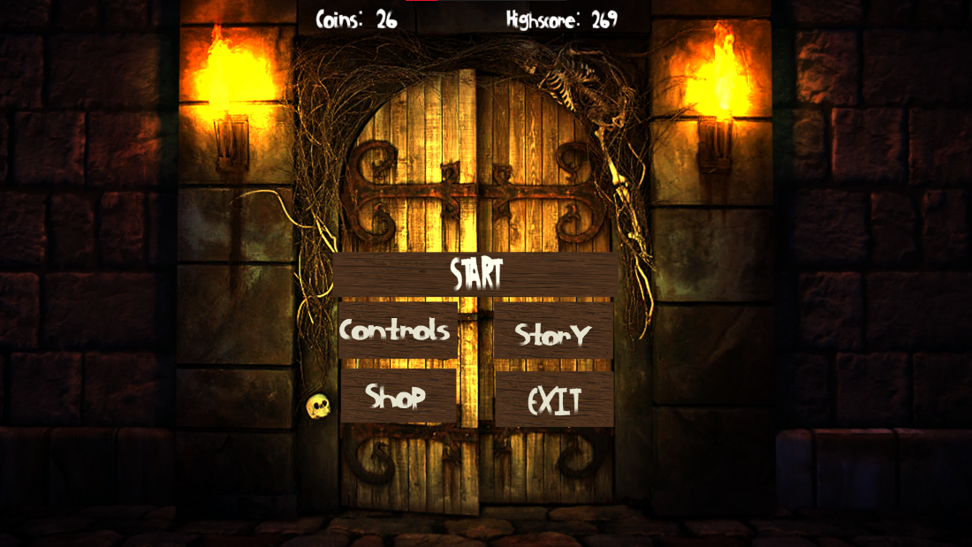

Main menu

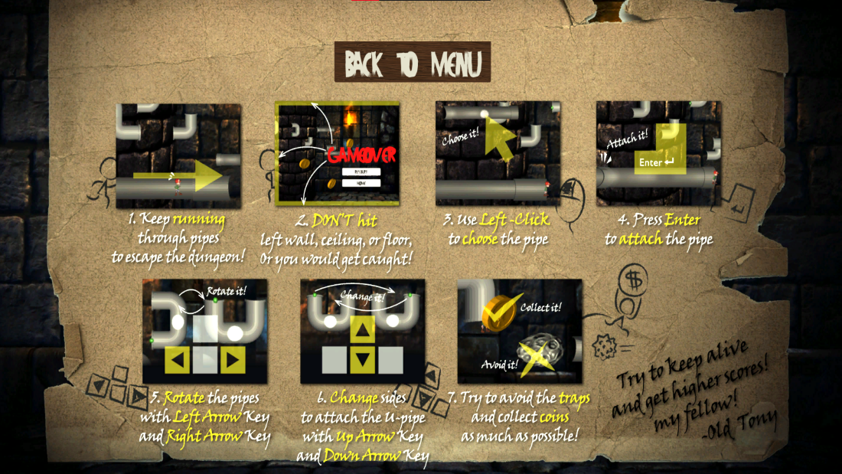

Controls

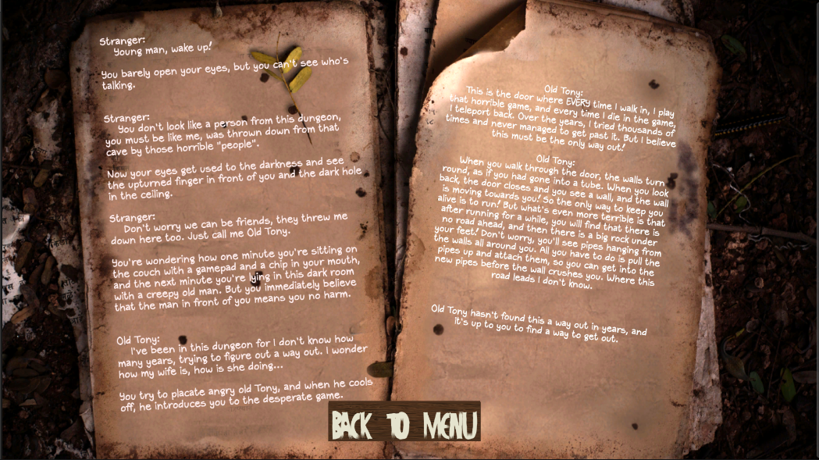

Story

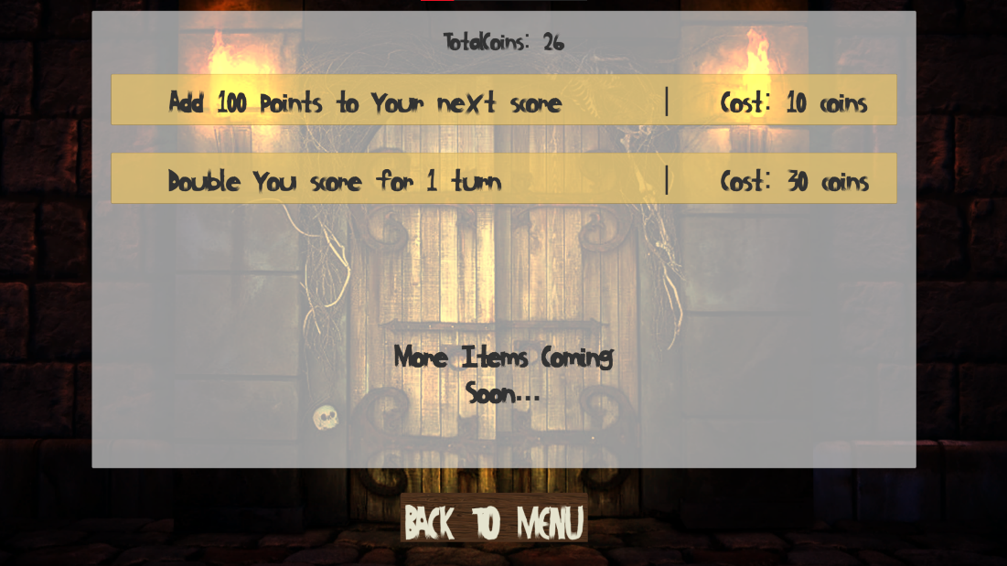

Coin Shop

## **Exception Handling**

The challenges we faced during this sprint’s tasks are outlined below, alongside their respective solutions:

|  |  |  |
| --- | --- | --- |
| Tasks | Challenges | Solutions |
| S7-T1 | The change in character position was too subtle to be recognised. | Move the code from Update() to FixedUpdate() to increase the time between when it is called. |
| S7-T2 | High Score text was not updating. | Accidently had a second script that was used as a placeholder that was overwriting the high score to 0 every time the menu was loaded. |
| S7-T3 | Renaming files and classes lead to lots of errors in trying to run the game and GitHub Merging. | Make sure all class names and script names are the same.  Recreate a new development branch on GitHub. |
| S7-T5 | N/A No challenges. | N/A |
| S7-T6 | N/A No challenges. | N/A |
| S7-T6 | The button on the main menu was not acting correctly. | The child text object of the button had a large blank text box that would trigger the button if clicked, so the size of the text box needed to be reduced to fit the button size. |
| S7-T8 | N/A No challenges. | N/A |
| S7-T9 | The saved values were being loaded every time the menu scene started, even after a death, so if the player had a higher score, it would still default to the saved value. | Only load the values from the save files once, by only doing it if the current values are lower than those that are saved (this will only happen if the player has just launched the game), for coin count this had to be slightly altered once the player had the ability to spend coins. |
| S7-10 | Implementing the bonus points into the score proved harder than expected, the score would not show correctly, it would either only state the bonus score or increase far too quickly. | I solved the issue by adding setting the additional bonus score in the start function than adding this score each update frame, to keep it from being lost. For the multiplier I set a separate Boolean, this was required so the score multiplier could be toggled to off once it had been used, but the score would still contain the multiplier for the remainder of that turn. |
| S7-T11 | N/A No challenges. | N/A |
| S7-T12 | N/A No challenges. | N/A |
| S7-T13 | Finding the right level of detail to add to the guide, how much experience does the reader have? | Give a well-balanced view, with some of the unity basics explained, but with additional resources suggested if the user does not have much experience. |
| S7-T13 | Ensuring there wasn’t too much repetition in the guide. | Compared all scene/script descriptions to identify any similarities, then added references to those above. |
| S7-T14 | N/A No challenges. | N/A |
| S7-T15 | N/A No challenges. | N/A |
| S7-T16 | N/A No challenges. | N/A |